**Experiment No: 1**

|  |
| --- |
| **Student Name and Roll Number: Avtar Singh / 20csu241** |
| **Semester /Section: 5th / FSB** |
| **Link to Code:** |
| **Date: 8/3/2022** |
| **Faculty Signature:** |
| **Marks:** |

|  |
| --- |
| **Objective(s):**  To familiarize the students to Linux interface. |
| **Outcome:**   * The students will understand commands used in Linux. |
| **Problem Statement:**  Implement the following things:   * Cygwin Installation * Basic Linux commands |
| **Background Study:**  Cygwin is a open source tool which provides that functionality of the Linux in windows Operating System. Cygwin is a large collection of GNU and Open Source tools which provide functionality similar to a [Linux distribution](https://en.wikipedia.org/wiki/Linux_distribution) on Windows. It is a DLL (cygwin1.dll) which provides substantial POSIX API functionality. |
| **Question Bank:**   1. **What is Linux?**   Ans : Linux® is an open source operating system (OS). An operating system is the software that directly manages a system's hardware and resources, like CPU, memory, and storage. The OS sits between applications and hardware and makes the connections between all of your software and the physical resources that do the work.   1. **How will you List files from a directory?**   Ans : The ls command is used to list files. "ls" on its own lists all files in the current directory except for hidden files.   1. **How files in a directory can be removed?**   Ans : 1. To remove an empty directory, use either rmdir or rm -d followed by the directory name: rm -d dirname rmdir dirname.  2. To remove non-empty directories and all the files within them, use the rm command with the -r (recursive) option: rm -r dirname.   1. **How to find out a word in a file?**   Ans : Grep is a Linux / Unix command-line tool used to search for a string of characters in a specified file.   1. **What are wildcards?**   Ans : A wildcard is a symbol that takes the place of an unknown character or set of characters. |

**Student Work Area**

**Algorithm/Flowchart/Code/Sample Outputs**

**Commands :**

**1.** **uname => Displays Linux system information**

**2. uname -r => Displays kernel release information**

**3. uptime => Displays how long the system has been running including load average**

**4. hostname => Shows the system hostname**

**5. hostname -i => Displays the IP address of the system**

**6. last reboot => Shows system reboot history**

**7. date => Displays current system date and time**

**8. timedatectl => Query and change the System clock**

**9. cal => Displays the current calendar month and day**

**10. w => Displays currently logged in users in the system**

**11. whoami => Displays who you are logged in as**

**12. finger username => Displays information about the user**

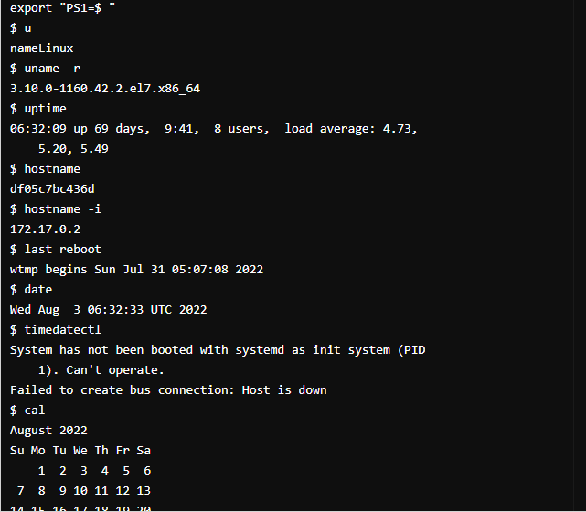

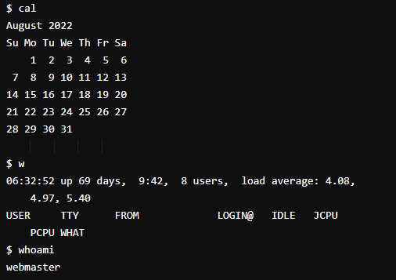

**Hardware**

**13. dmesg => Displays bootup messages**

**14.cat /proc/cpuinfo => Displays more information about CPU e.g model, model**

**name, cores, vendor id**

**15 .cat /proc/meminfo => Displays more information about hardware memory e.g.**

**Total and Free memory**

**16. lshw => Displays information about system’s hardware configuration**

**17. lsblk => Displays block devices related information**

**18. free -m => Displays free and used memory in the system (-m flag**

**indicates memory in MB)**

**19. lspci -tv => Displays PCI devices in a tree-like diagram**

**20. lsusb -tv => Displays USB devices in a tree-like diagram**

**21. dmidecode => Displays hardware information from the BIOS**

**22. hdparm -i /dev/xda => Displays information about disk data**

**23. hdparm -tT /dev/xda => Conducts a read speed test on device xda**

**24. badblocks -s /dev/xda => Tests for unreadable blocks on disk**

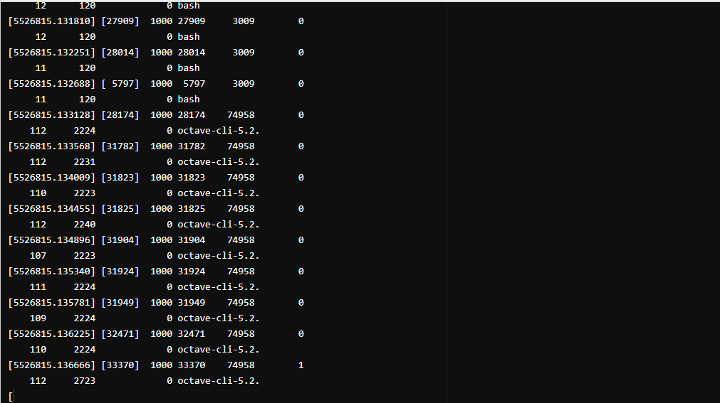

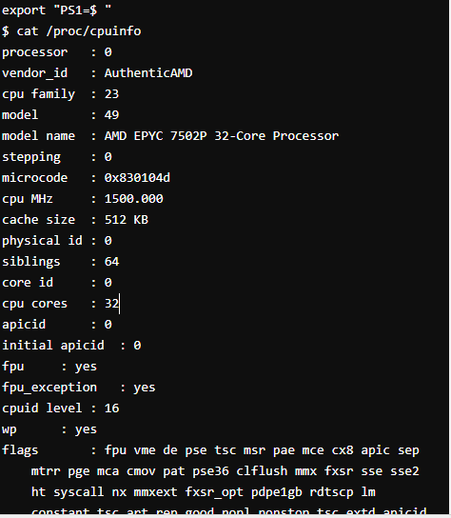

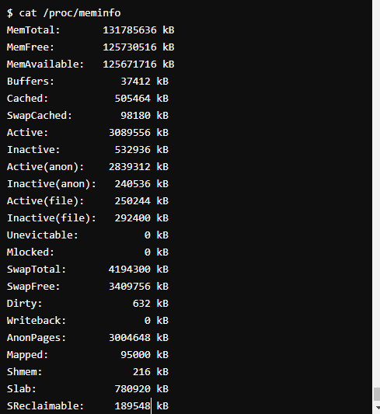

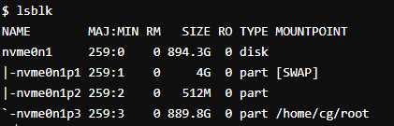

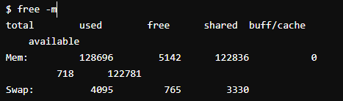

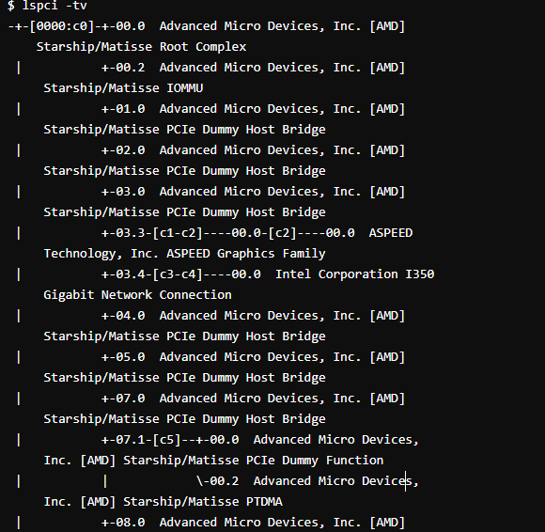

**User**

**1. id => Displays the details of the active user e.g. uid, gid, and**

**groups**

**2. last => Shows the last logins in the system**

**3.who => Shows who is logged in to the system**

**4. groupadd “admin” => Adds the group ‘admin’**

**5. adduser “Sam” => Adds user Sam**

**6. userdel “Sam” => Deletes user Sam**

**7. usermod => Used for changing / modifying user information**

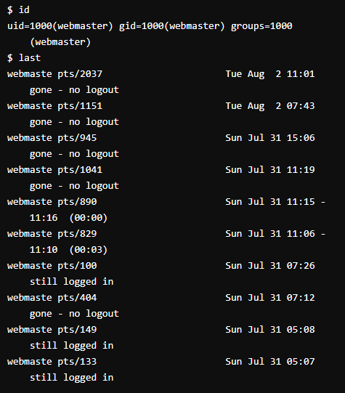

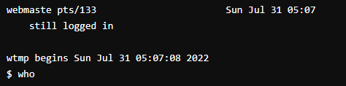

**File Commands**

1. **ls -al => Lists files - both regular & hidden files and their permissions as well.**
2. **pwd => Displays the current directory file path**
3. **mkdir ‘directory_name’ => Creates a new directory**
4. **rm file_name => Removes a file**
5. **rm -f filename => Forcefully removes a file**
6. **rm -r directory_name => Removes a directory recursively**
7. **rm -rf directory_name => Removes a directory forcefully and recursively**
8. **cp file1 file2 => Copies the contents of file1 to file2**
9. **cp -r dir1 dir2 => Recursively Copies dir1 to dir2. dir2 is created if it does not**

**exist**

1. **mv file1 file2 => Renames file1 to file2**
2. **ln -s /path/to/file_name**
3. **link_name**
   * **Creates a symbolic link to file_name**
4. **touch file_name => Creates a new file**
5. **cat > file_name => Places standard input into a file**
6. **more file_name => Outputs the contents of a file**
7. **head file_name => Displays the first 10 lines of a file**
8. **tail file_name => Displays the last 10 lines of a file**
9. **gpg -c file_name => Encrypts a file**
10. **gpg file_name.gpg => Decrypts a file**
11. **wc => Prints the number of bytes, words and lines in a file**
12. **xargs => Executes commands from standard input**

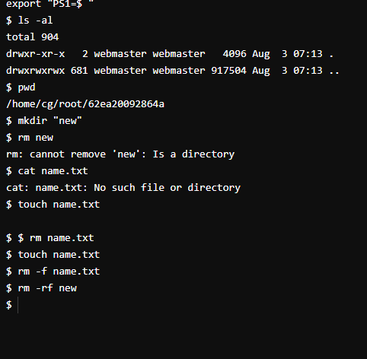

**EXPERIMENT NO. 2**

|  |
| --- |
| **Student Name and Roll Number: Avtar Singh - 20csu241** |
| **Semester /Section:5th / FSB** |
| **Link to Code:** |
| **Date:10/08/2022** |
| **Faculty Signature:** |
| **Marks:** |

|  |
| --- |
| **Objective:**  To write the shell programming code for the following. |
| **Outcome:**  Student is able to write code in shell programming |
| **Problem Statement:**  a) Write A Shell Program of Hello World  b) Write a shell program to find factorial of a number.  c) Write a shell program to find gross salary of an employee.  d) Write a shell program to display the menu and execute instructions accordingly  **(i)**List of files **(ii)**Process Status **(iii)** Date **(iv)** users in program **(v)** Quit |
| **Background Study:**  A shell script is a file with a set of commands in it. The shell reads this file and executes the instructions as if they were input directly on the command line.  A shell is a command-line interpreter and operations such as file manipulation, program execution and text printing is performed by shell script. So, we will use vi editor to edit our files. |
| **Question Bank:**   1. **What is a shell?**   Ans. The shell is **the layer of programming that understands and executes the commands a user enters**.   1. **What is the significance of $#?**   Ans.$# **shows the count of the arguments passed to the script**   1. **What are the different types of commonly used shells on a typical Linux system?**  * Ans.The Bourne Shell (sh) * The GNU Bourne-Again Shell (bash) * The C Shell (csh) * The Korn Shell (ksh) * The Z Shell (zsh)  1. **How will you pass and access arguments to a script in Linux?**   Ans.Arguments can be passed to the script when it is executed, **by writing them as a space-delimited list following the script file name**. Inside the script, the $1 variable references the first argument in the command line, $2 the second argument and so forth. The variable $0 references to the current script.   1. **Use sed command to replace the content of the file (emulate tac command) ?**   **sed -i 's/old-text/new-text/g' input.txt** |

**Student Work Area**

**Algorithm/Flowchart/Code/Sample Outputs**

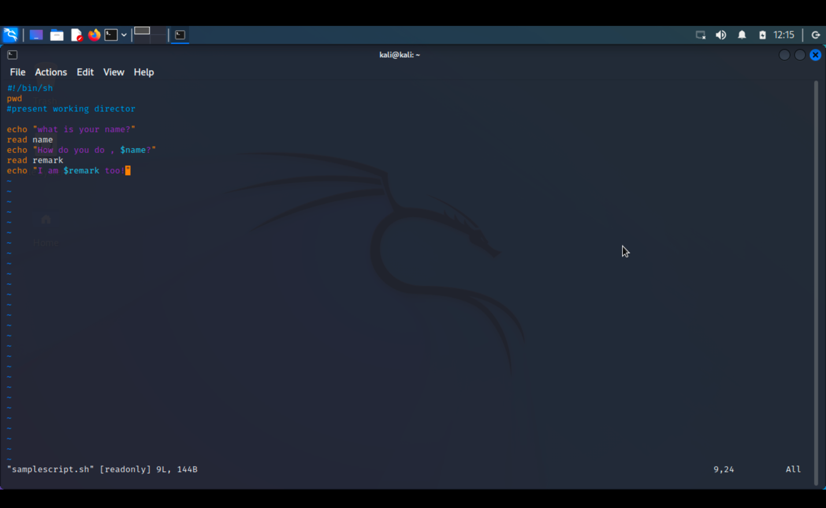

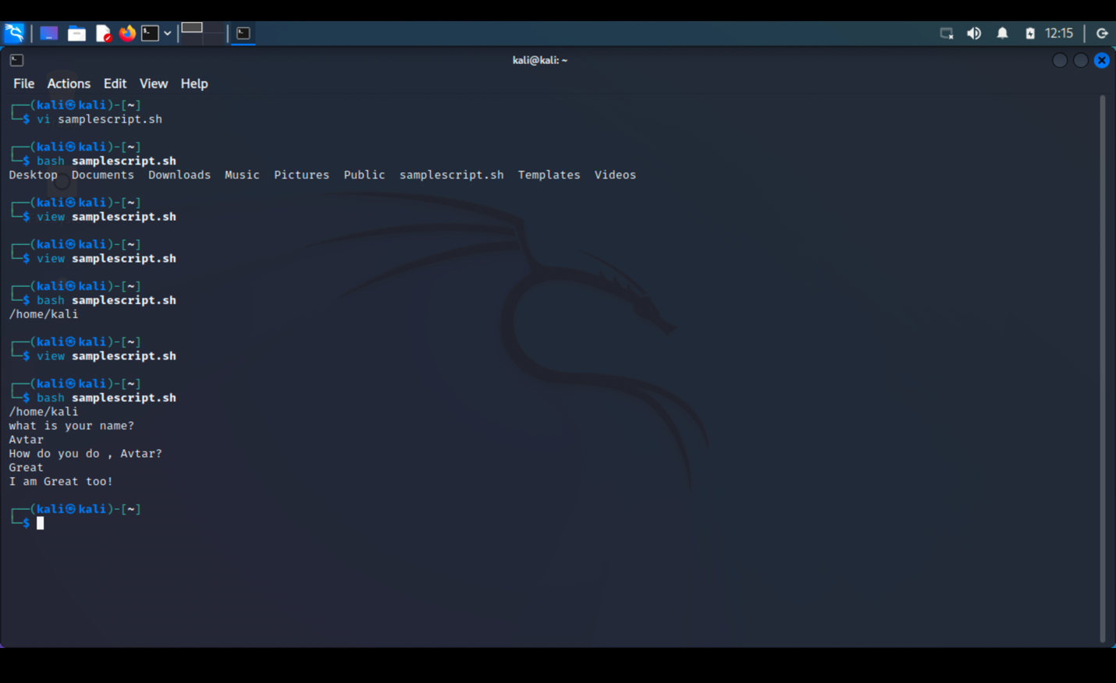

a) Write A Shell Program of Hello World

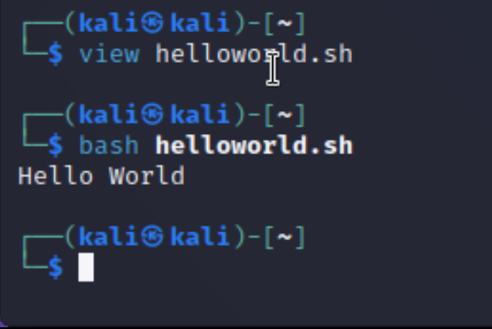

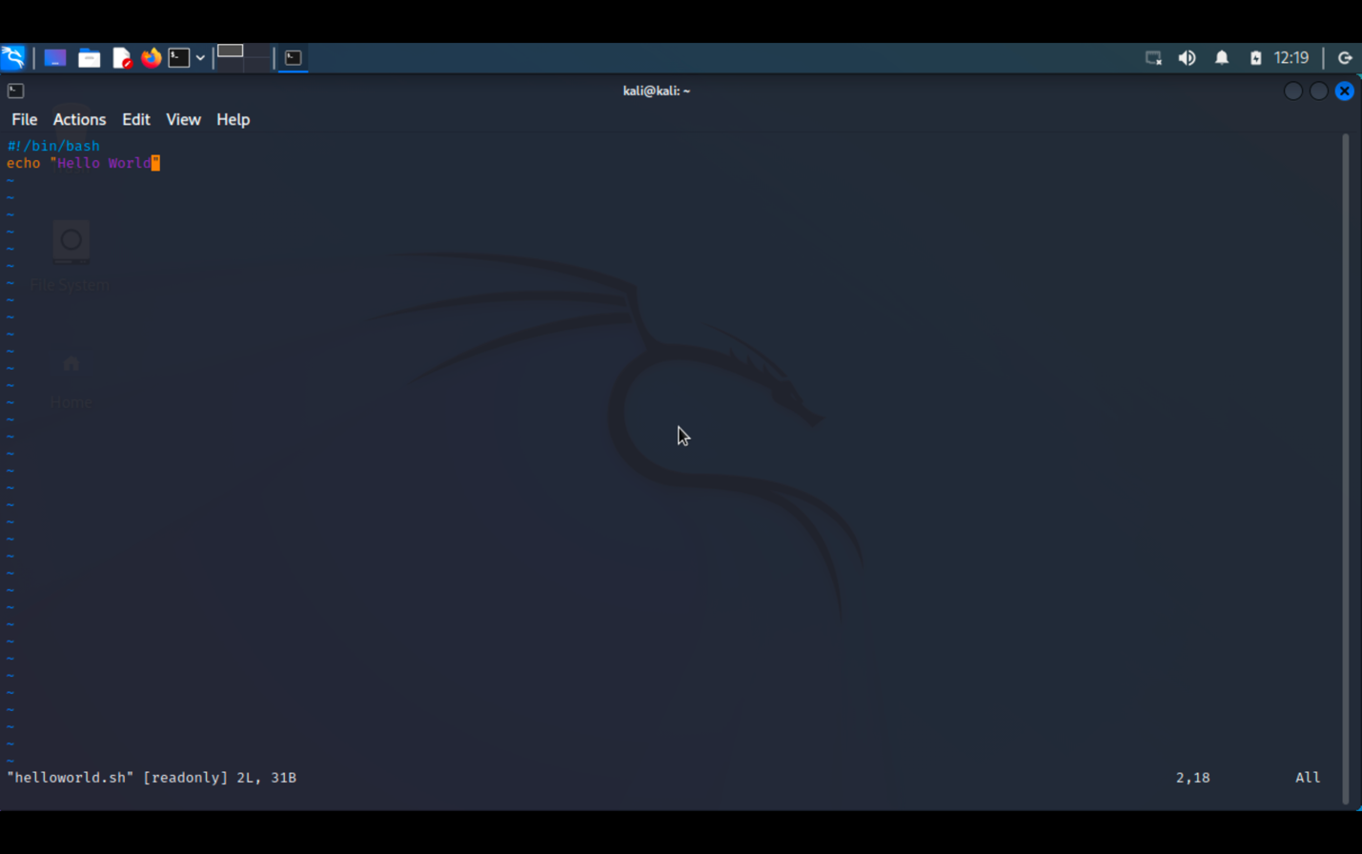

b) Write a shell program to find factorial of a number.

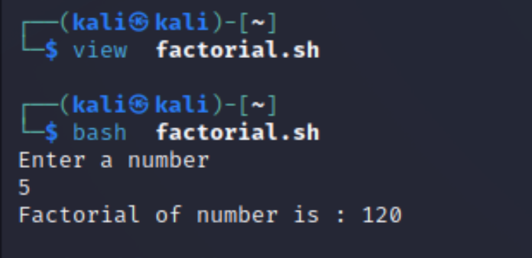

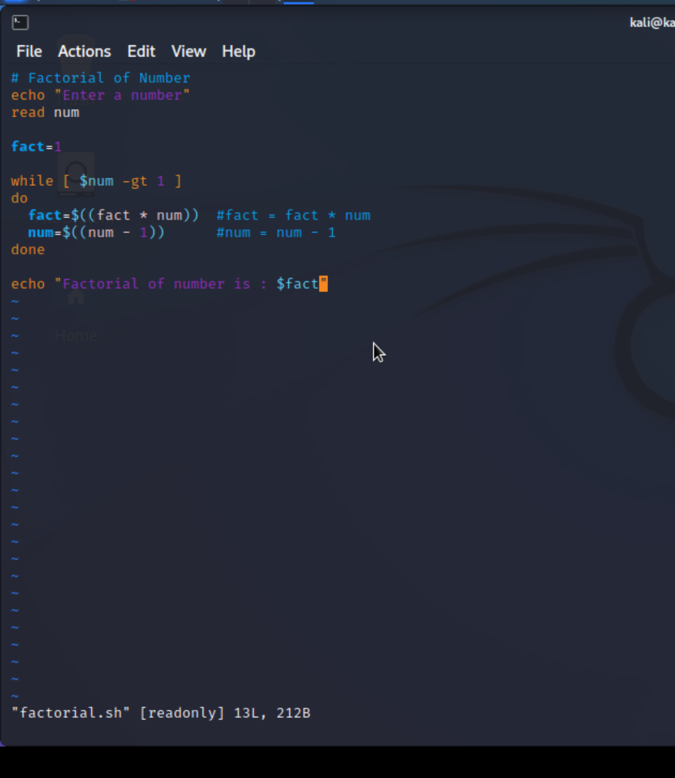

c) Write a shell program to find gross salary of an employee.

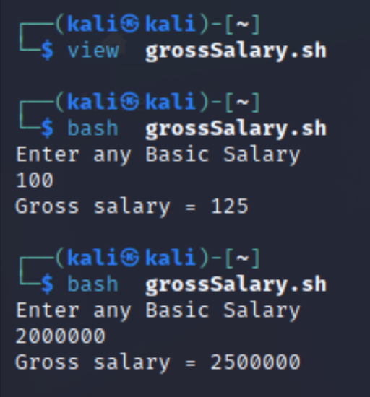

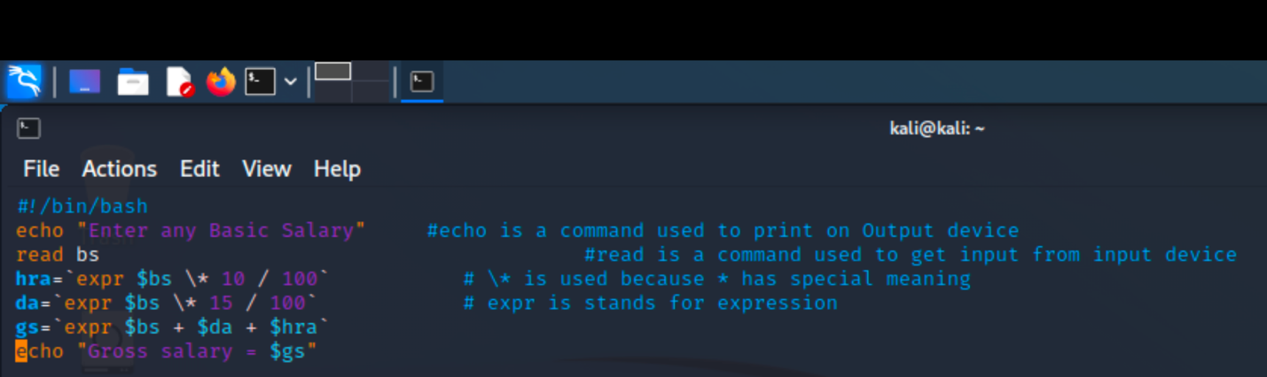

d) Write a shell program to display the menu and execute instructions accordingly

**(i)**List of files **(ii)**Process Status **(iii)** Date **(iv)** users in program **(v)** Quit

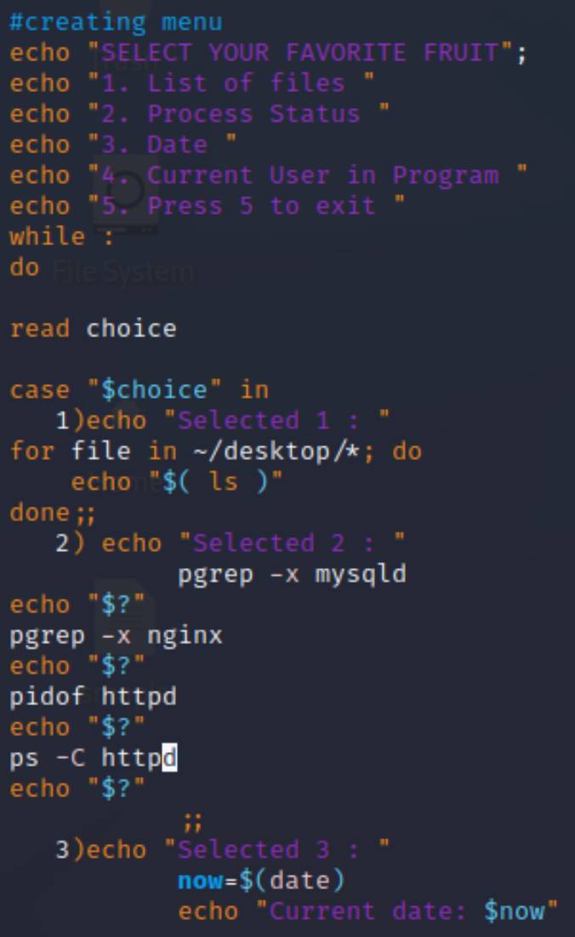

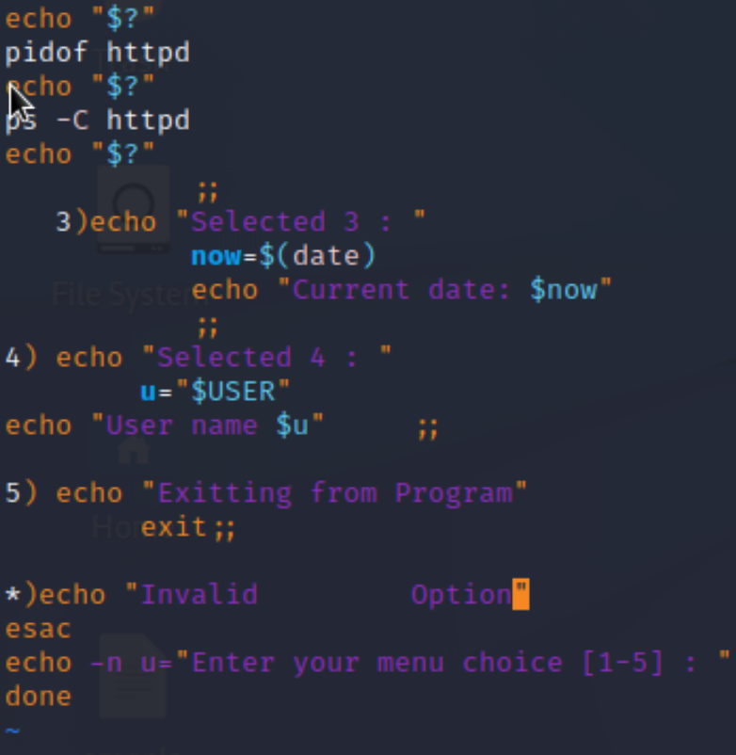

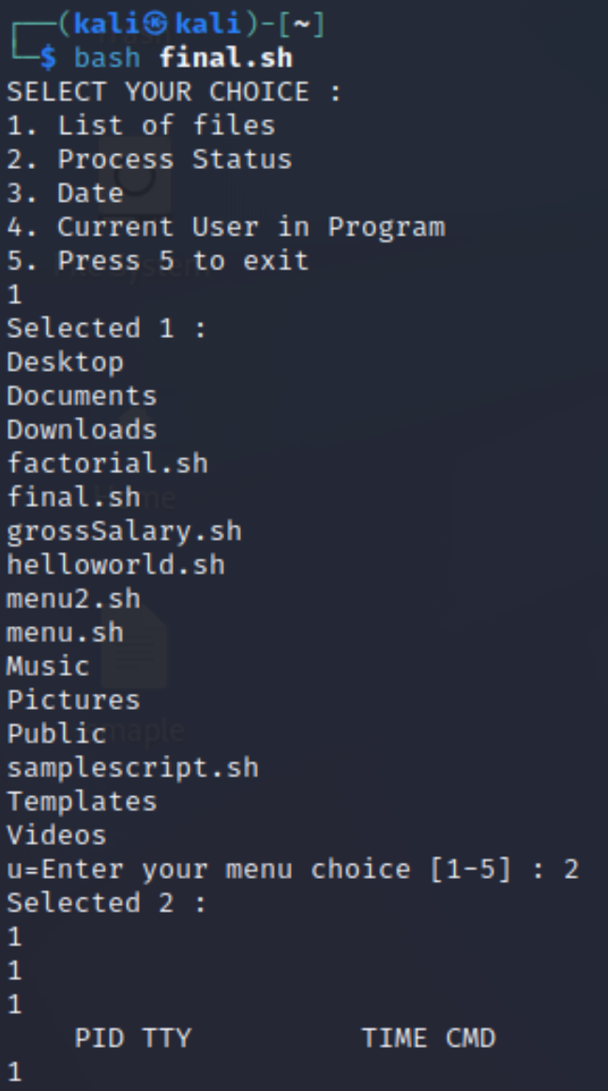

**EXPERIMENT NO. 3**

|  |
| --- |
| **Student Name and Roll Number: Avtar Singh - 20CSU241** |
| **Semester /Section: 5th / FSB** |
| **Link to Code:** |
| **Date: 24/08/2022** |
| **Faculty Signature:** |
| **Marks:** |

|  |
| --- |
| **Objective:**  To write the shell programming code for the following. |
| **Outcome:**  Student is able to write code in shell programming |
| **Problem Statement:**  a) Write a shell program to find Fibonacci series.  b) Write a shell program to find largest of three numbers.  c) Write a shell program to find average of N numbers |
| **Background Study:**  A shell script is a file with a set of commands in it. The shell reads this file and executes the instructions as if they were input directly on the command line.  A shell is a command-line interpreter and operations such as file manipulation, program execution and text printing is performed by shell script. So, we will use vi editor to edit our files. |
| **Question Bank:**   1. **How to use multi line comments in shell script?**   Ans : In Shell or Bash shell, we can comment on multiple lines **using << and name of comment**. we start a comment block with << and name anything to the block and wherever we want to stop the comment, we will simply type the name of the comment.   1. **What is the difference between soft and hard links?**   Ans : A hard link is a file all its own, and the file references or points to the exact spot on a hard drive where the Inode stores the data. A soft link isn't a separate file, it points to the name of the original file, rather than to a spot on the hard drive.   1. **Explain about loops and what are the loops available in LINUX?**   Ans : The for loop **operates on lists of items**. It repeats a set of commands for every item in a list.  There are **three types of shell loops** in UNIX/Linux: for loop. while loop. until loop.  You will use different loops based on the situation. For example, **the while loop executes the given commands until the given condition remains true; the until loop executes until a given condition becomes true**.   1. **What are absolute and relative paths.**   Ans : **An absolute path is defined as specifying the location of a file or directory from the root directory(/)**. In other words,we can say that an absolute path is a complete path from start of actual file system from / directory. Relative path is defined as the path related to the present working directly(pwd).   1. **How to debug a shell script.**   Ans : The debugging options available in the Bash shell can be switched on and off in multiple ways. Within scripts, we can either use the set command or add an option to the shebang line. However, another approach is to explicitly specify the debugging options in the command-line while executing the script. |

**Student Work Area**

**Algorithm/Flowchart/Code/Sample Outputs**

a) Write a shell program to find Fibonacci series.

Program :

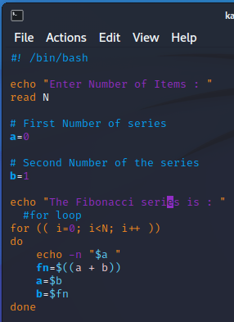

Output :

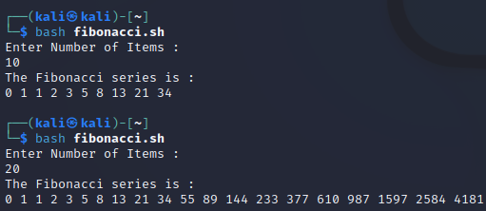

b) Write a shell program to find largest of three numbers.

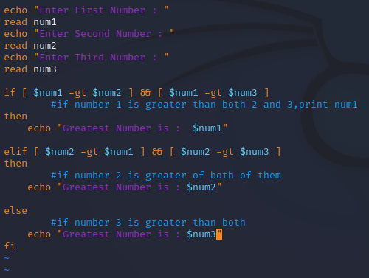

OUTPUT :

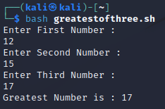

c) Write a shell program to find average of N numbers

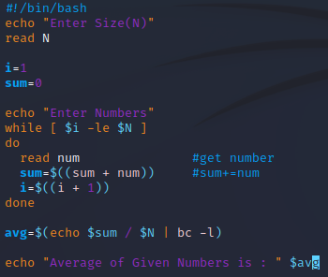

**Output :**

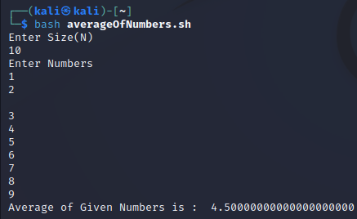

**EXPERIMENT NO. 4**

|  |
| --- |
| **Student Name and Roll Number: Avtar Singh - 20csu241** |
| **Semester /Section: 5th /FSB** |
| **Link to Code:** |
| **Date:** |
| **Faculty Signature:** |
| **Marks:** |

|  |
| --- |
| **Objective:**  To write the shell programming code for the following. |
| **Outcome:**  Student is able to write code in shell programming |
| **Problem Statement:**  a) Write a shell program to check whether a number is even or odd  b) Write a shell program to find whether a number is prime or not.  c) Write a shell program to find whether a number is palindrome or not.  d) Write a shell program to type number 1 to 7 and then print its corresponding day of week |
| **Background Study:**  A shell script is a file with a set of commands in it. The shell reads this file and executes the instructions as if they were input directly on the command line.  A shell is a command-line interpreter and operations such as file manipulation, program execution and text printing is performed by shell script. So, we will use vi editor to edit our files. |
| **Question Bank:**   1. What are Zoombie Process?   On Unix and Unix-like computer operating systems, a zombie process or defunct process is a process that has completed execution (via the exit system call) but still has an entry in the process table: it is a process in the "Terminated state".   1. What are different types of variables used in shell script?   Two types of variables can be used in shell programming: Scalar variables. Array variables.   1. What are the different types of modes available in Vi editor? 2. Command Mode 3. Insert Mode 4. Escape Mode 5. What are the different types of permission at file level in shell?   1)Owner Permission  2)Group Permission  3)Other (World) Permission   1. How to use comments in shell script. # |

**Student Work Area**

**Algorithm/Flowchart/Code/Sample output**

a) Write a shell program to check whether a number is even or odd

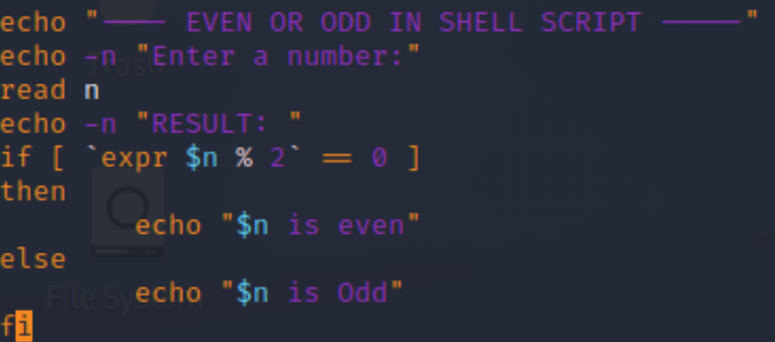

b) Write a shell program to find whether a number is prime or not.

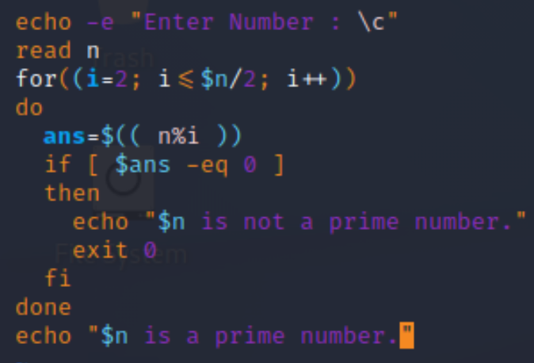

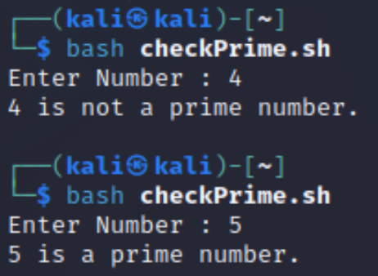

c)Write a shell program to find whether a number is palindrome or not.

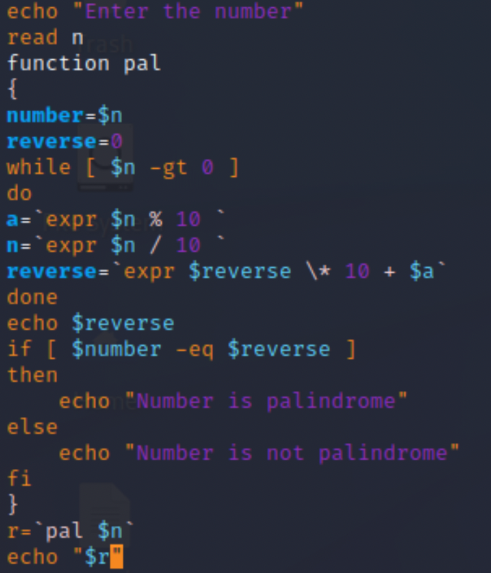

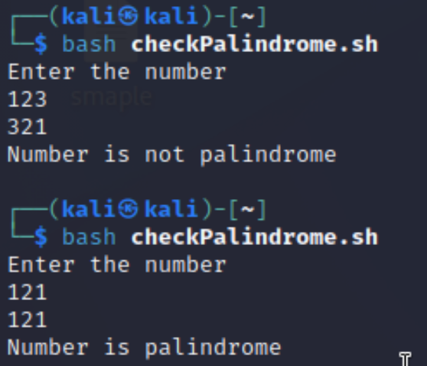

d) Write a shell program to type number 1 to 7 and then print its corresponding day of week

